Uganda 2017
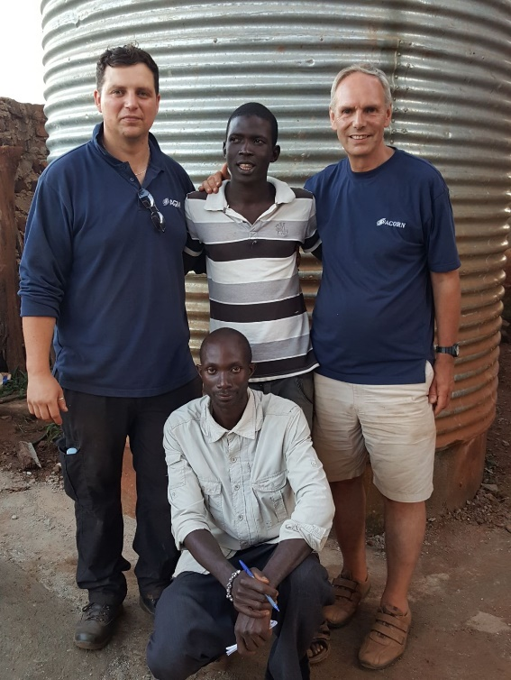
After over 2 years of planning, organising and fund raising on May 19th we were off to Uganda us and a group from Beacon Christian Centre based in Loughborough totalling 11 people. 02:30 start from Birmingham Airport to Amsterdam, then to Rwanda in central Africa and south of the equator. A quick stop, and then final leg to Entebbe, Uganda. 22:30 mini bus to accommodation 2 hours away. We were all very tired.
Saturday - up to exchange our cash (4160 UGS to the pound) then off on a feeding program at a small village called Kisoga, 2 hours away. This village is very poor and is struggling to feed themselves. Pastor Joseph took us to see one young man nearby who he was very proud of - he has tried to make a better life for himself by breeding pigs. He’s lost two sow’s during mating with an unsuitable boar from a nearby farm. We had an impromptu meeting and decided to provide the money to buy his own boar. This will become a source of income for him and be safer for his sow’s. He was extremely happy as he didn’t ask for anything from us, just to hear his story.
Back in the village the food was served to the people and we played with the children. It’s amazing what happy chaos a handful of balloons, toys and sweets can cause. There was a plan to get to Alpha and Omega school to get our first glimpse of the well, however we quickly realised that there is no plan A, B or Z in Uganda, just plan A continually modified. There are many stories from this village, aids, malaria, lack of food and water are constant problems here and we saw first-hand how they combine to effect people and families.
Sunday – a church day for everyone. We travelled to Salama, another poor village where Alpha and Omega school is located and made it to the school in the afternoon. The school acts as a safe place for the children, and has been built up over 15 years from humble beginnings operating out of wooden huts. It’s grown to 350 children now with purpose built brick buildings, and operates as an orphanage for children who have no one to look after them as well as a boarding school for children whose parents can afford the small fee. One of the challenges for the school has been keeping the children safe when walking to the nearby communal spring. There is a certain belief regarding a cure for aids that is taught by some in these area that puts children in a great danger.
Beacon Christian Centre has supported this school and encouraged it to grow. Part of this work, supported specifically by Keith Daikin of Loughborough University, has been to have a well dug within the school walls. Out of this well the water is pumped. However, the electricity is expensive and the supplies unreliable. We later found out that the cost of running this pump is the equivalent to half a local tradesman’s salary every day. Brown outs and black outs are frequent, and the area has just come out of the worst drought for 50 years. The cost of operation and reliability of the pump has meant that the children needed to go to the spring more and more often putting them at risk and interrupting their school days.
During the drought period the well had been dug deeper to guarantee a water supply even during the driest times, and there is every confidence that the well will provide water to the school should a similar drought happen. This led to our first look at the well head, it was encased in concrete. Which makes sense to keep the children safe, but was one scenario that hadn’t been thought of. The job also increased in size as supplying other rainwater storage and standpipes in the school grounds were added to the wish list, again plan A modified. We made a parts list and wondered where we could locate such parts, after all BSS don’t have a Uganda branch.
Monday – Travel to Jinja 40 miles away to collect the solar panels as arranged via E-mail from Davis and Shirtliff. Pastor Joseph, now our driver didn’t know the way. So, thanks to Google maps and a stop to ask for directions we found them. Those 40 miles took over two hours on Ugandan roads, but it was worth it and Matovu was extremely helpful. This was a common theme in Uganda and was a pleasant thing to have to get used too. With the solar panels loaded Matovu walked us down the road to the local plumbing supplier. Now for any of the shops in Uganda picture a Sunday market or car boot stall but located in a building. Most of the time they are open fronted and they seem to be open all night. If there is something valuable in the shop there may be security with an antiquated rifle complete with rust, pits and rotten stock. Still I wouldn’t like to be anywhere near the business end of the thing should the owner decide to use it, pointed at me or not. This particular plumbing supplier either didn’t need security or couldn’t afford it. Either way it was an Aladins cave and may not of had everything we wanted, but it had everything we needed. A careful drive back followed with Phil under the panels, Keith with a quarter of a seat and Melvin up front sitting quite comfortably with Pastor Joseph.
Tuesday – and were headed to Alpha and Omega School via an electrical supplier (plan A modification). We tried to take with us all the parts that we thought we might need packed in yellow carryalls, however even back at home it’s not possible to foresee all eventualities and this was another one… we needed earth cable, and a lot of it. By now we had gotten used to things costing less than at home so when it came to buying cable the price was a shock. A quick look at it though and we realised why, “made in England”.
On arrival to the school it was all hands to (fitting) the pump, Michael, our local tradesman had cleared the concrete and moved the cap from the well head and everyone pitched in over the next two days.
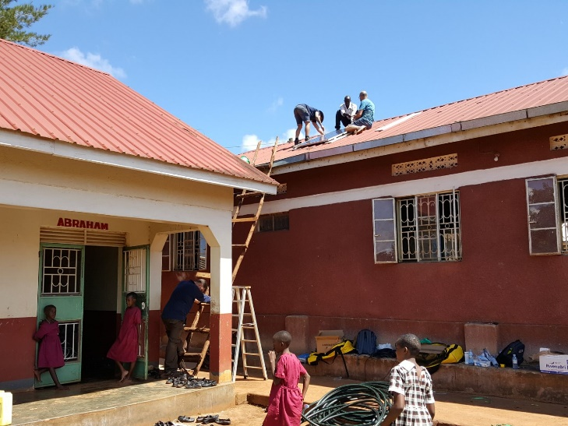
The solar panels were lifted and mounted onto corrugated tin roofs; the control panel mounted to the wall; cable routed through the building and holes made by repeatedly hitting a metal bar with a homemade hammer; pipework measured cut and fitted; Trenches, pipework and fittings sorted for the standpipes; it all came together nicely and the team worked excellently together.
The well was deeper than expected, but this was designed in:
- ground to water level 7m
- water level to the bottom of the well 11m
- 4m from ground to the top of the tank
At 48VDC the pump will produce 7b closed head and 1900L/hr. During the day-time we measured the solar panels will produce 69VDC with the controller regulating the supply to the pump. Float switches were fitted to the pump as low-level protection and the storage tank as a pump control.
Once the light faded we had to stop work, and we headed back to Pastor Joseph and his wife Ruth’s home for food, something that was a happy end to each day.
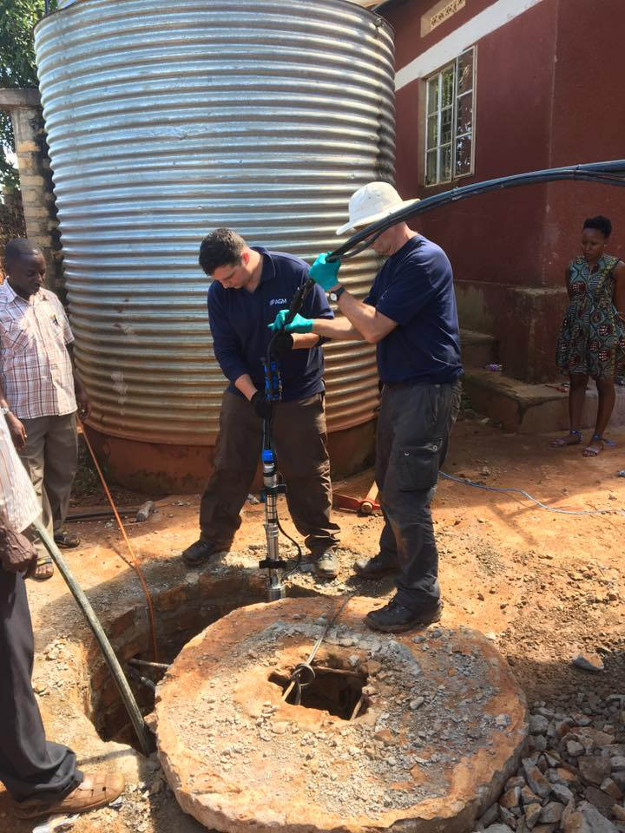
Wednesday – time to finish the work started on Tuesday, switch on and test. However, there was a problem… it didn’t work! With a little fault finding, quiet contemplation, an open end and change of wiring polarity the pump started with Paul and Keith looking down the open end. I’m not sure if it was the heat or relief but I’m pretty sure they had never been more relived to get a soaking before.
With just enough light left in the day to test the pump operation the pump was working with a good flow, and it soon filled the storage tank.

This was two thirds of the way through, and during the rest of the trip we visited two other sister school’s to Alpha and Omega, one is right at the start of the project and is located where roads don’t exist, and paths and tracks are animal trails. There are very few buildings and they are made from mud and rough sawn wood and it was explained to us it was a good example of the starting point of Alpha and Omega school.
The second school is somewhere in between with some brick buildings. Neither have a safe source of water, and a dangerous walk to springs. But it showed that with a little work and support big changes can be made.
The villages based around these schools are very poor, and to put that in context their clothes are rags and can be sacrificed to form a kind of bag to carry away a gift of rice. The schools in these area’s give these people hope for a better future and provide support and aid where they can.
One thing that struck us all was that everyone is trying to make their way. Their whole time is given up to finding food and water, or to earn enough for food and water. There is no attitude that someone will give them what they need or “I’m not doing that”, everyone is doing their best to make a living, even if it involves picking 1kg of tea leaves for 1 pence. Their gratitude towards what we would consider a small gift, their generosity of spirt, their energy for life and joy knows no limits and is truly uplifting.
There are many more stories that can be shared, but hopefully this will give you a taster and it’s a good time say thank you to everyone at AGM and all who have been supportive and interested in the project.
Thank you
Phil Cotton
Melvin Cotton
Beacon Christian Centre, Loughborough

